Hasmonean Coin Classification

Project Book

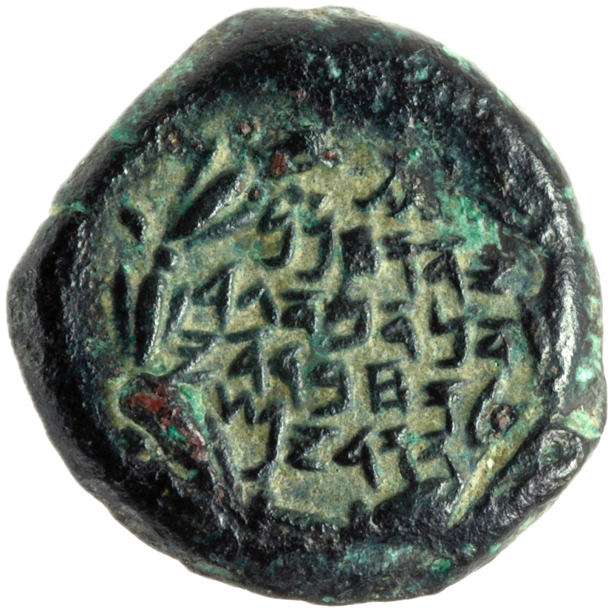

Team Members:

Student - Barak Finkel 206491714

Student - Nikita Breslavsky 332363498

University Mentor – Prof. Lee-Ad Gottlieb

IAA Researcher – Yanniv David Levy

***Abstract***

This project investigates the use of deep learning for automating the identification of inscriptions on Hasmonean coins. Initially, YOLO-based models were applied to detect and classify individual letters, with the dataset refined through repeated experiments. The letter data was then used to train a secondary model to classify the ruling Hasmonean leader associated with each coin. We evaluated several machine learning algorithms, including k-NN, Random Forest, SVM, MLP, and XGBoost, for this task. The results showed high accuracy, providing a strong foundation for applying object detection models to ancient coins and setting the stage for further research and optimization.

***Introduction***

Hasmonean coins were minted by the Hasmonean dynasty, a Jewish ruling family that governed Judea between the 2nd and 1st centuries BCE following the Maccabean Revolt. These coins, typically made of bronze, often featured Hebrew inscriptions, symbolizing Jewish independence from Hellenistic rule. Unlike the contemporary Greek and Roman coins that depicted rulers' portraits, Hasmonean coins primarily displayed symbols such as cornucopias, pomegranates, anchors, and menorahs, reflecting both Jewish religious themes and regional influences. The inscriptions were written in Paleo-Hebrew and included the names of Hasmonean rulers and titles like "High Priest" and "Council of the Jews", emphasizing their political and religious authorities. These coins remain valuable artifacts for understanding the history, economy, and cultural identity of the Hasmonean period.

Historically, experts have manually classified coins by analyzing their unique features, a process that demands both time and specialized knowledge. With the rise of deep learning, this task can now be automated by training models to detect patterns in coin images. These AI-driven approaches not only speed up identification but also improve accuracy, making it easier to organize and study large collections. This technological advancement provides historians and archaeologists with powerful tools to uncover insights about ancient economies, trade networks, and cultural influences.

This project focuses on creating a model capable of identifying 13 distinct letters found on historical coins. Beyond achieving high accuracy in letter classification, we also developed a secondary model that analyzes the predicted letter annotations to determine which ruler the coin represents. This paper outlines our approach, experimental process, and findings, while also exploring the historical and cultural significance of the Hasmonean era.

***Historical Background: Hasmonean Dynasty Coinage***

The Hasmonean Dynasty, established by the Maccabees, was a Jewish ruling family that gained independence from the Seleucid Empire in the 2nd century BCE. Emerging from the Maccabean Revolt, the Hasmoneans ruled Judea for over a century, expanding their territory and solidifying Jewish self-governance. Their reign marked a significant period of political and religious autonomy before the eventual Roman intervention.

***The Importance of Coinage in the Hasmonean Period***

Coinage played a crucial role in the administration and economy of the Hasmonean state. As a newly independent kingdom, issuing coins was a powerful assertion of sovereignty. Hasmonean coins often featured Hebrew inscriptions, reflecting Jewish identity and distinguishing them from the Greek and Hellenistic coinage of surrounding powers. Unlike earlier coins that bore the images of rulers or deities, Hasmonean coins typically displayed symbols such as palm branches, cornucopias, and pomegranates, which held religious and cultural significance. These coins also carried the names of Hasmonean rulers, often alongside titles like "High Priest" or "Council of the Jews," making them valuable sources for dating archaeological sites and understanding the political shifts of the period.

### ***Dataset Description***

#### ***Overview of the Image Dataset*** For this project, we used a dataset consisting of 907 images of Hasmonean coins, all showing the obverse side that contains the textual inscriptions. Each image was meticulously selected to ensure high quality, enabling the model to identify detailed patterns, and focusing only on coins with mostly legible letters. Typically, the obverse side of these coins displays the ruler's name, which serves as the primary distinguishing feature between the coins of different Hasmonean rulers.

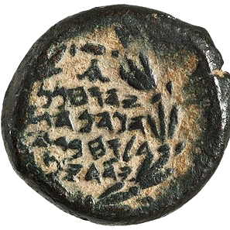









### ***Challenges in Identifying Coin Letters***

Identifying letters on the coins is a challenging task due to several factors. First, the large number of letters present on each coin adds complexity to the identification process. Second, the shapes of the letters occasionally closely resemble one another, further complicating differentiation. Additionally, the wear and tear some coins have endured over time can obscure important details, making it difficult to distinguish between letters and leaving gaps in the data that our model must interpret. Lastly, subtle variations in lettering style across different periods or rulers often require expert knowledge to identify.

For our project, we collaborated with Yaniv Levy, a numismatic expert at the Israel Antiquities Authority (IAA), who provided valuable insights into the coin images we studied and contributed the letter annotations within the coins to enhance the efficiency of the process.

***The Hasmonean Rulers:***

In this project, we sampled coins of 3 different rulers during the Hasmonean Period:

* ***John Hyrcanus***:

John Hyrcanus, who ruled from 134 to 104 BCE, expanded the Hasmonean kingdom and strengthened Jewish religious practices. His reign is marked by territorial conquests, including Idumea, and efforts to consolidate Jewish control. He also played a key role in reinforcing the influence of the Jewish faith during his rule.

* ***Judah Aristobulus***:

Judah Aristobulus ruled briefly from 104 to 103 BCE and was the first Hasmonean ruler to adopt the title of king. His reign focused on consolidating power and maintaining the kingdom’s territorial gains, laying the groundwork for future Hasmonean leadership.

* ***Alexander Jannaeus***:

Alexander Jannaeus ruled from 103 to 76 BCE and is known for expanding the Hasmonean kingdom through military campaigns. His reign was also marked by internal challenges, particularly with the Pharisees, but he worked to strengthen the monarchy and the Hasmonean state.

***Task I: Letter Detection and Classification***

***Methodology***

***Data Sources:***

The images of the coins were taken from the IAA's datasets, as well as from various museum and auction websites that were authenticated by the IAA for further work, including:

* *https://www.coinarchives.com*
* *https://www.cngcoins.com*
* *https://www.britishmuseum.org/collection*
* *https://museum.imj.org.il/imagine/collections*

***Data Cleaning and Preprocessing:***

Before training the model, the raw coin images underwent both local preprocessing and cloud preprocessing via Roboflow to ensure consistency and reliability in the training data. This involved several key steps:

* ***Image Extraction and Isolation***: Each coin image was extracted from the image background using OpenCV's image segmentation tools.
* ***Preprocessing***: The extracted images were then converted to grayscale and had their sharpness increased via Histogram Equalization.
* ***Multiplication and Augmentation***: To improve model performance and add variance in both texture and directionality, the images were multiplied by 5 in quantity by utilizing the following techniques:
* Directionality – Each unique image was rotated 90°, 180° and 270°. Additionally copies of these versions of the images were created by rotating by a random number of degrees between -45° and 45°.
* Blurring – Each version underwent a Gaussian Blur of a randomly selected factor between 0 and 1 per image.

***Class Selection:***

For this project, we aimed to accurately classify instances of the fourteen letters visible on the coins: Bet, Gimel, Dalet, Hei, Vav, Het, Yod, Kaf, Lamed, Mem, Nun, Resh, Taf, and the Roman Alpha (added in later experimentation stages).

To minimize potential bias, we selected coins from the reigns of the three different rulers, ensuring an as even distribution as possible (50/25/25 ratio). Additionally, the coins were chosen to include a wide range of textural variations.

***Training Ratio:***

For the base dataset proportions, we chose a 70/20/10 training-validation-test ratio to ensure reliable evaluation and testing.

***Using Roboflow.com for Cloud-Training:***

We worked with Roboflow.com for the Hasmonean coin project. The platform provided an intuitive environment to organize, annotate, and preprocess the data, facilitating a smooth workflow between us and the IAA for annotation and training. Its seamless integration with deep learning frameworks on a cloud server made training and testing the model straightforward, playing a crucial role in the process of classifying the letters on the Hasmonean coins.

***Deep Learning Models:***

For this project, we utilized YOLOv8/11 alongside Roboflow 3.0 to effectively detect and classify the letters on our data.

* ***YOLOv11*** is a powerful deep learning model currently still in development, but known for its speed and accuracy in object detection tasks. It operates by dividing the input image into a grid and predicting bounding boxes and class probabilities for each grid cell, enabling real-time detection. Given its efficiency in handling complex, multi-object environments, YOLOv11 was well-suited for detecting the various letters and features present on our coins.
* We also experimented with the ***Roboflow 3.0*** model, which produced even better results. This model is built on techniques derived from ***YOLOv8***, the predecessor of YOLOv11, and is widely recognized for its fast and accurate labeling capabilities.

Both models' outputs are filtered based on a predefined confidence threshold, displaying only class instances predicted with a confidence level exceeding this value.

Additionally, the model applies an overlap percentage threshold to handle multiple letter detections within the same area. If the overlap between detected letters exceeds the threshold for any of them, only the letter with the highest confidence score is retained, minimizing ambiguity and enhancing accuracy.

To ensure consistency, we set a fixed confidence threshold of 75% and an overlap threshold of 35% for evaluating the model's performance at any stage up until finalizing the model.

Roboflow’s cloud-based integration with these models optimized the workflow, enabling efficient training of our Hasmonean coin dataset on high-performance hardware, significantly reducing training time. This setup allowed the model to capture intricate details of the inscriptions, making it a crucial tool for accurately distinguishing letters and inscriptions across various coin types.

***Metrics:***

The metrics chosen for training and testing the model's efficiency were mAP (The mean average precision over the validation set in all epochs of each training session), and the precision and recall over the test set. These metrics are derived from two primary factors: bounding box placement & size loss and class error loss. The model’s loss function combines these components into a single unified loss metric.

***Model Output:***

A JSON file containing detected letter classes, bounding box coordinates, confidence scores, and image metadata. This structured output enables precise extraction of letter distributions across different coins. By analyzing these patterns, the data can be further processed to support the identification of the ruling Hasmonean leader, making it a valuable step in the classification workflow.

***Initial Experiment: The Letter 'Nun'***  
To initially assess the effectiveness of YOLOv11 for the project, we started by integrating a pre-trained version into our framework and fine-tuning it for the letter detection task, without any preprocessing the images beyond resizing the images to a consistent size.

We began by annotating only the letter 'Nun' and created a dataset with approximately 40 images associated with John Hyrcanus featuring the letter. This approach resulted in a test mAP of 67%, which was a promising outcome considering the worn condition of the coins, the limited size of the dataset, and the presence of many other letters on each coin.



*Results with a 50% confidence threshold

***Second Experiment: Dataset Expansion***

Building on the promising initial results, we shifted our focus to a new question: How would the model perform when detecting a much larger set of letter classes? Would adding all remaining letters improve accuracy or introduce confusion? Following advice of our mentor, we decided to test this expansion in a single shot, rather than gradually increasing the number of classes.

The experiment was conducted on a dataset of approximately 360 images, each fully annotated to distinguish all letters. The images were evenly sampled from the three rulers’ reigns and were in relatively good condition, with clear and legible inscriptions. We applied the same preprocessing and augmentation techniques as before, with the addition of 90° and 270° rotations.

Surprisingly, the model performed even better with multiple classes, achieving an mAP of 79.4%, a precision of 83.8%, and a recall of 68.3%. This reinforced our belief that further dataset expansion could lead to even greater improvements, bringing the model closer to practical application.

However, we also observed that its performance varied depending on the textural properties of the coins. For example, the model struggled to accurately predict letters that were fragmented or not clearly defined against the background, especially when they were lighter in color.

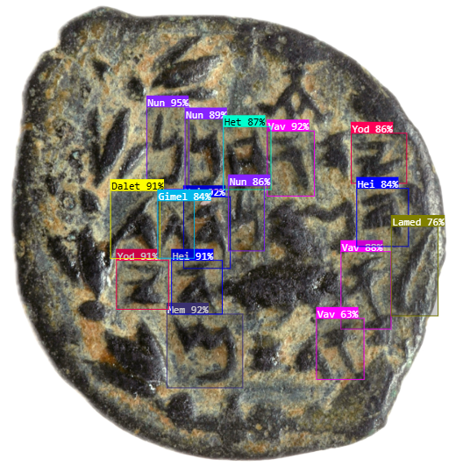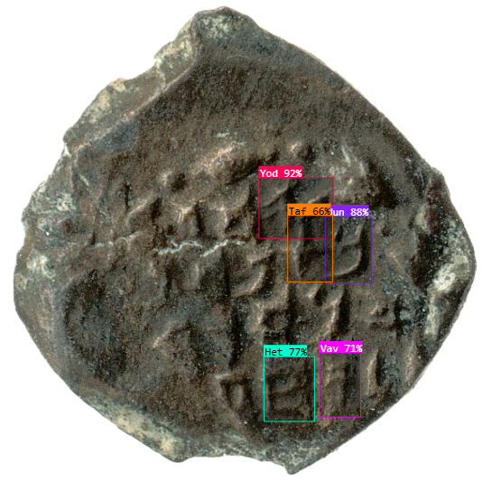

*Results for a 50% confidence threshold

Next, we decided to further expand the dataset in both volume and textural variance to enhance the model's efficiency and robustness.

***Third Experiment: Emphasis on 'Nun' and 'Kaf'***

As we continued annotating additional coins for training, we observed more clearly how similar certain letters appeared. This led us to conduct an experiment to assess the model’s ability to differentiate between the letters 'Nun' and 'Kaf.'

The experiment was performed on approximately 500 images, evenly sampled from the reigns of the three rulers, using the same preprocessing methods as before. The model achieved an mAP of 80%, with a precision of 82.7% and a recall of 70.4%. Surprisingly, the model did not confuse the two letters as much as anticipated, though it did fail to detect many instances of both.

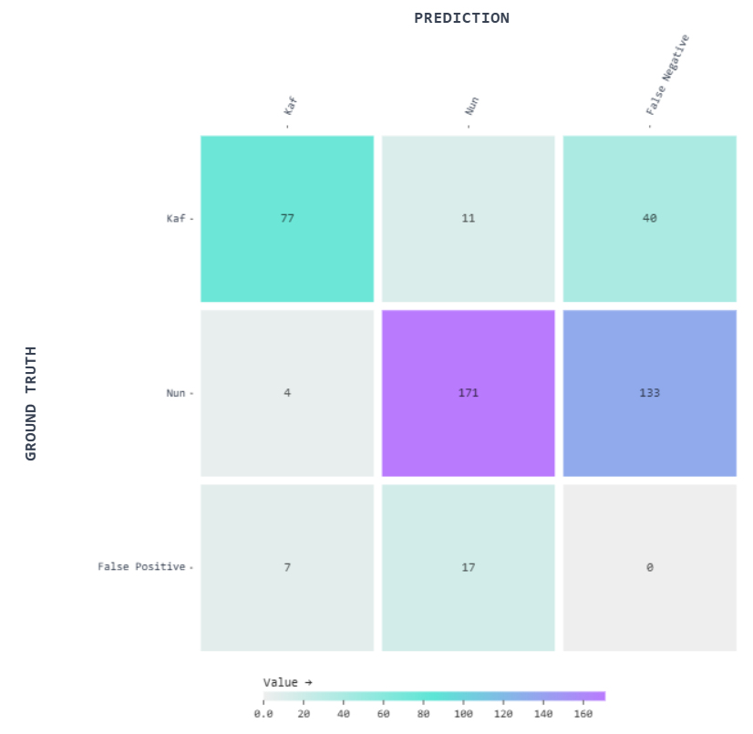

***Affirmation of Historical Claims:***Throughout the project, it became evident that certain engravers of specific font styles did not establish clear distinctions between certain letter pairs, such as 'Kaf' and 'Nun' in many coins minted during Judah Aristobulus' reign. This observation reinforced the notion that some of these engravers may not have been native readers or writers of the Paleo-Hebrew language inscribed on the coins, a fact reflected in the stylistic inconsistencies of the lettering.



***Fourth Experiment: Further Dataset Expansion & Addition of the Letter 'Alpha'***

We then added additional images to the dataset, until arriving at approximately 500 images available for training. We also added the roman letter 'Alpha' to our classification task. This letter appears in most of the coins of John Hyrcannus, although it is not part of the Paleo-Hebrew lexicon. While the algorithm did not previously mistake this symbol for other letters, we wanted to test if its annotation would add precision to the model’s overall results.

In this experiment, the model achieved an mAP of 83.4%, a precision of 86.9%, and a recall of 73.9%, marking an improvement over previous attempts. Unfortunately, optimization became increasingly difficult, as adding significantly to the dataset's training images yielded quite diminishing returns, suggesting the model was approaching a performance plateau. However, despite the small number of around 80 samples containing the letter 'alpha', its predictions reached an admirable mAP of 81%.

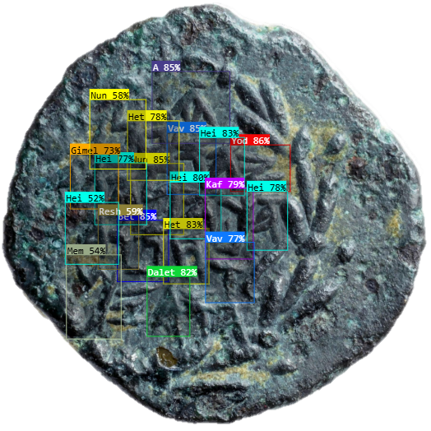

*Results for a 50% confidence threshold

***Final Experiment: Data Expansion at Expense of Ruler Sample Ration***

At this stage of the project, our base dataset had reached a limitation, as we lacked enough well-preserved images of John Hyrcanus and Alexander Jannaeus' coins to further expand the training set. To enhance the model’s performance, and following our mentor’s advice, we decided to forgo the even distribution among rulers and incorporated more images of Judah Aristobulus' coins, as well as images of coins with no evident leader that they represent. This adjustment resulted in a training dataset of 907 images, whilst having a 48/23/23/6 (Aristobulus / Hyrcanus / Jannaeus / Unidentified) ratio between the rulers’ sampled coins within our training dataset.

Additionally, we omitted 90° and 270° rotations based on the intuition that they were unnecessary, as the vast majority of coins in the dataset were already oriented at either 0° or 180°.

The model achieved an mAP of 89.6%, a precision of 88.7%, and a recall of 82.8%, marking the effort a success. Below is the confusion matrix of the latest version of the model’s classification predictions:

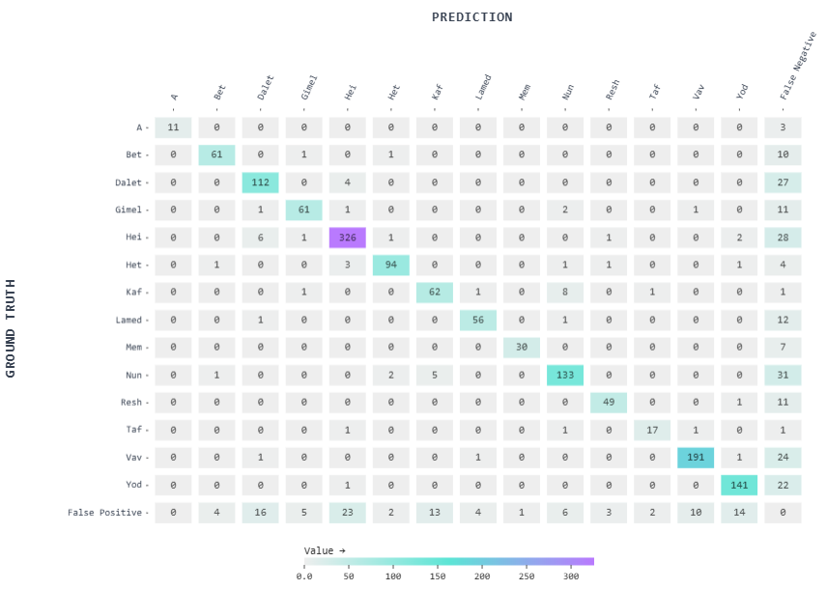

***Conclusions Over Model Confusion:***

To further evaluate the model's remaining challenges, we used Roboflow's Vector Analysis to identify coins where predictions were the least accurate. As expected, the model struggled with coins that exhibited uncommon characteristics within the training dataset, such as significant wear, relatively rare font styles within the dataset (examples below).

However, another portion of the detected errors were not actual misclassifications but rather discrepancies caused by minor annotation mistakes in the dataset. Additionally, in some cases the model correctly identified letters that we initially could not classify ourselves, and upon closer inspection, its predictions were found to be accurate.



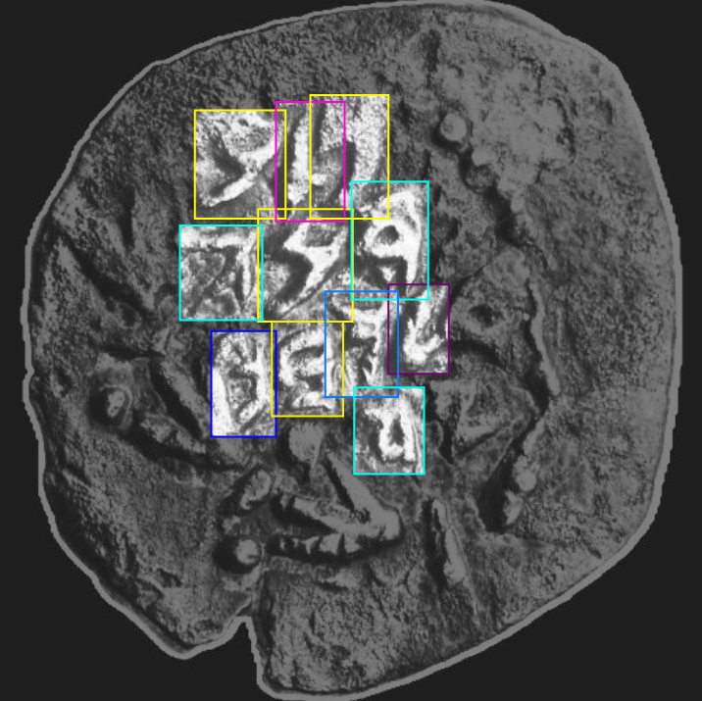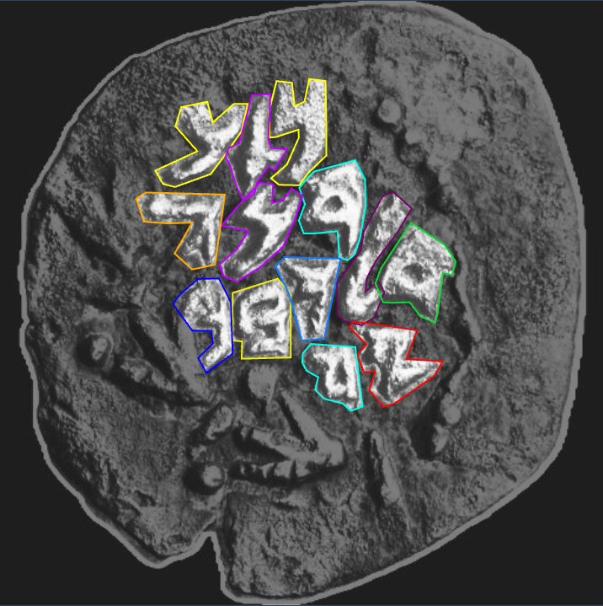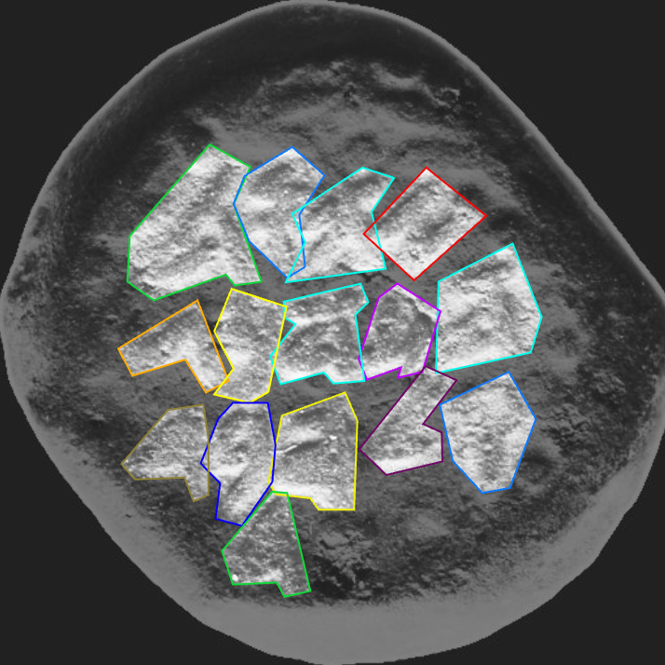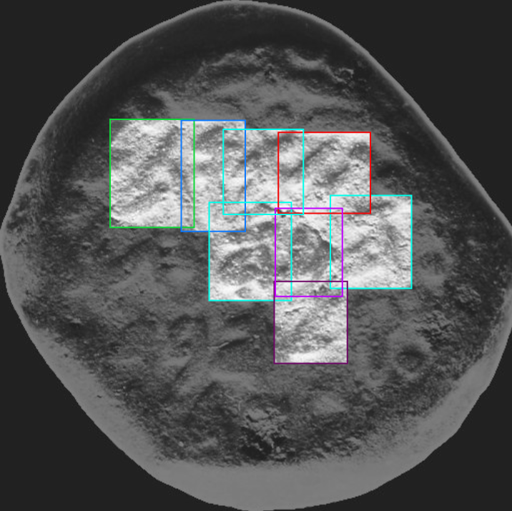

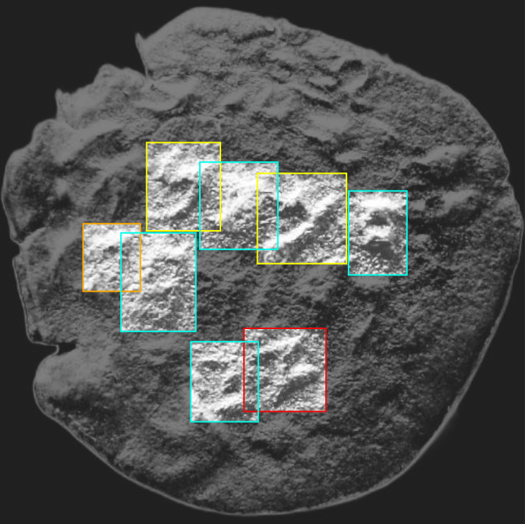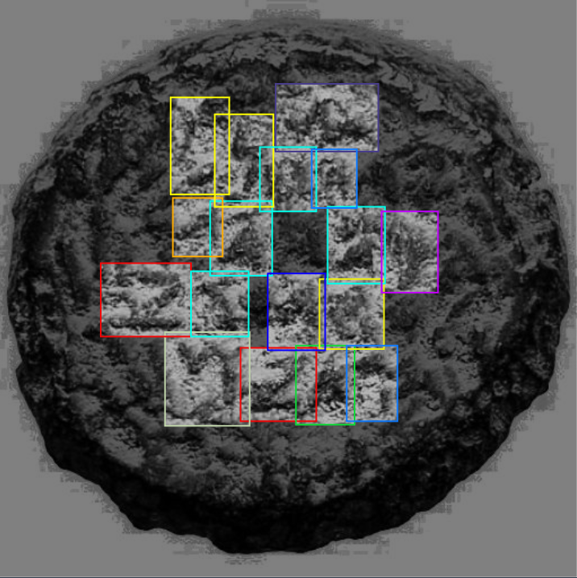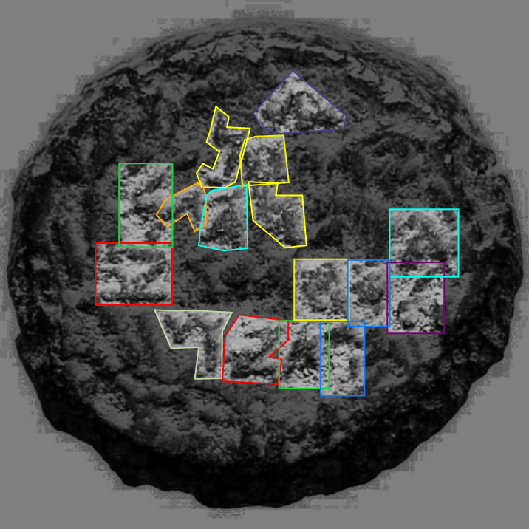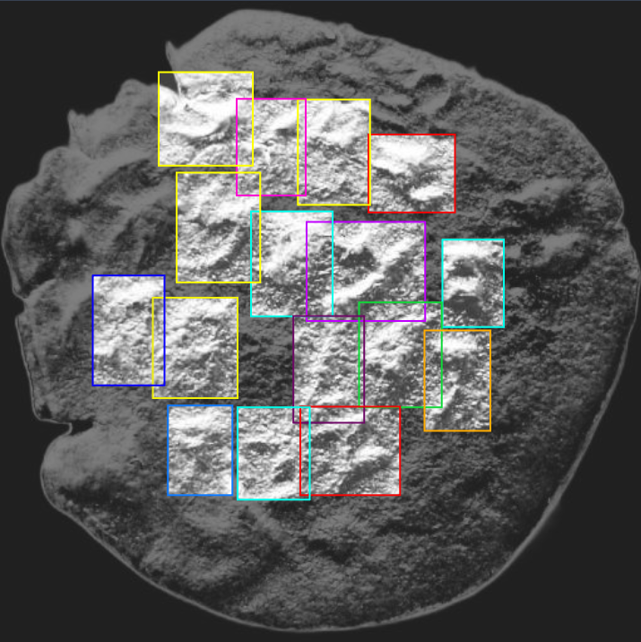

*Results for a 40% confidence threshold

***Task II: Hasmonean Ruler Classification***

Building on the success of the letter detection model, we advanced to the final objective: identifying the Hasmonean ruler associated with each coin. Since the model’s output provided annotation details for predicted letter classes, we leveraged this data by feeding it into a separate machine learning model designed for classification based on numerical features.

***Methodology***

***Preprocessing:***

To classify the Hasmonean ruler represented by each coin, we processed the JSON outputs from the letter detection model into structured numerical features. Each image was represented as a row in a 2D array, whereas different letters (e.g., ‘A’, ‘Bet’, ‘Resh’, etc.) had their own sets of feature columns. Features extracted for each letter included:

* *Count:*The number of instances of the letter within the image.
* *Position (AvgX, AvgY)*: The average coordinates of all occurrences.
* *Spread (StdX, StdY)*: The standard deviation of X and Y positions, indicating dispersion.
* *Box Ratio*: The aspect ratio of the bounding box enclosing the letter

Additional metadata from the JSON, including image size, was retained to enable feature normalization when needed. Note that position-based features might have required scaling, while count-based values remained unchanged for interpretability.

***Class Selection:***

After classifying individual letters, the next step was to identify the Hasmonean ruler associated with each coin - John Hyrcanus, Alexander Jannaeus, or Judah Aristobulus. Since this model builds upon the previous one, we preserved the approximate 48/23/23/6 distribution ratio of coins across the three rulers.

***Training Ratio:***

As with the letter classification model, we maintained a 70/20/10 ratio for training, validation, and testing. This ensured a balanced dataset for reliable evaluation and performance assessment.

***Testing Models:***

To achieve the best possible results, we employed cross-entropy as the loss function and tested a range of classic and deep machine learning models, including k-NN, Random Forest, SVM, MLP, and XGBoost.

***Metrics:***

Classic accuracy, i.e all correct predictions within all predictions.

***Model Output:***

The predicted ruler represented by the coin.

***Experimentation Results***

We have robustly created a single experiment to find the best possible results out of each model, and the results are as follows:

| Model | Best Parameters | Best Cross Validation Accuracy | Best Test Accuracy |
| --- | --- | --- | --- |
| k-NN | metric: manhattan  n_neighbors: 5  weights: distance | 88.57% | 90.80% |
| Random Forest | max_depth: None  min_samples_leaf: 1  min_samples_split: 2  n_estimators: 50 | 91.92% | 90.80% |
| SVM | C: 10  gamma: 0.1  kernel: rbf | 92.94% | 93.10% |
| MLP | activation: tanh  alpha: 0.01  hidden_layer_sizes: (100,_) | 93.20% | 93.10% |
| XGBoost | learning_rate: 0.2  max_depth: 10  n_estimators: 200 | 93.71% | 93.10% |

Following these promising results, we chose to use XGBoost as the classifier for our task.

***Feature Importance***

To identify which letters the model relies on most for ruler classification, we used its built-in method to calculate a feature importance metric. The results are as follows:

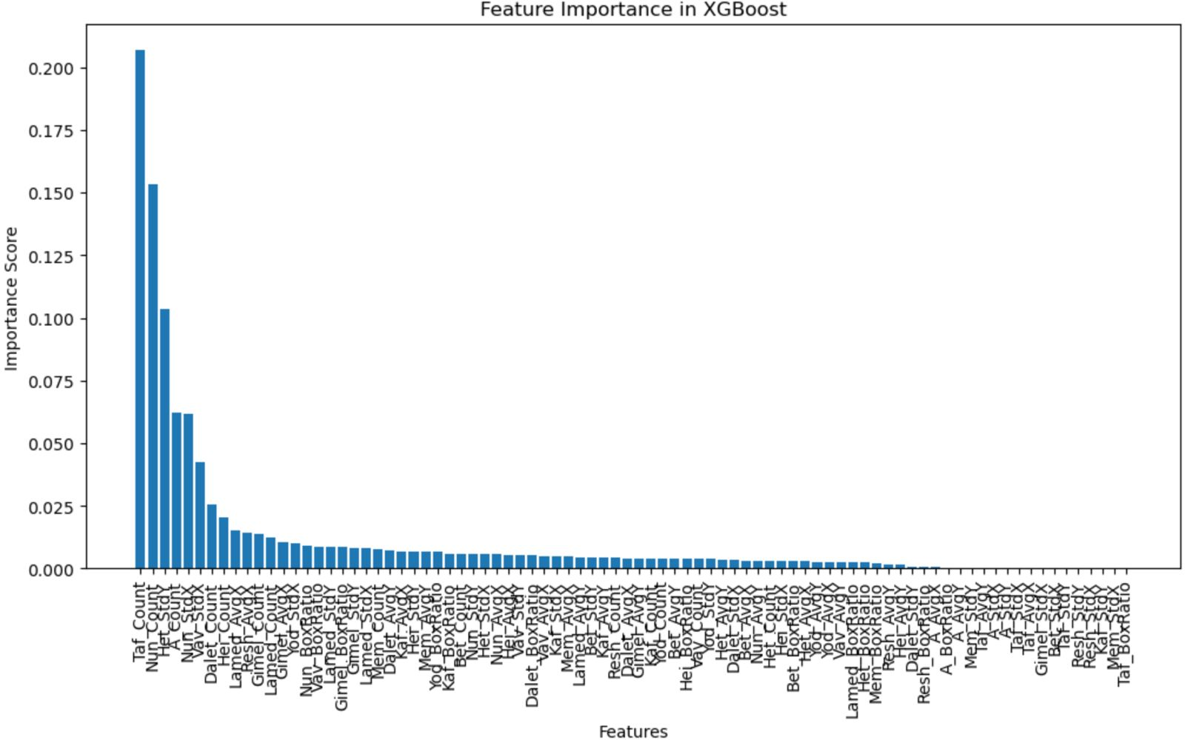

As expected, the letter ‘Taf’ proved to be the most significant, as it is the key identifier in manually classifying coins of Alexander Jannaeus, appearing exclusively on those minted during his reign.

Additionally, the letter ‘Nun’ also plays a crucial role in the model’s classification of a ruler. This is expected, as each Hasmonean ruler's coins contain a different number of occurrences of the letter ‘Nun.’ Moreover, its mean coordinates within the coin vary based on the ruler’s name, as the letter appears in predictable positions corresponding to the specific inscriptions of each reign.







An unexpected outcome, however, was that the letter ‘Alpha’ held a feature only ranking as the fourth most significant with a relatively low importance metric. Given that it appears exclusively on John Hyrcanus’ coins, since he was the only ruler who ordered its inclusion within coins minted throughout his rule (similarly to ‘Taf’’s exclusivity in Alexander Jannaeus’ coins), it was anticipated to have a stronger influence on classification.

***Bonus - Hasmonean Coin Classification Website***

To make the results of our model pipeline accessible and user-friendly, we developed a web-based platform that utilizes the output data from both the letter detection and ruler classification models. The website allows users to upload coin images, process them through the trained models, and receive detailed insights, including detected letters and the predicted Hasmonean ruler. By integrating the structured JSON outputs into an interactive interface, the platform provides a streamlined way to analyze coins, aiming to make the classification process more efficient and accessible to researchers and historians.

*https://hasmonean.streamlit.app*

***Conclusion***

In this project, we successfully developed a deep machine learning pipeline capable of detecting individual letters on Hasmonean coins and classifying the ruler associated with each coin with high success percentages.

By leveraging YOLOv8/11 for letter detection and integrating its structured output into the secondary classification model based on XGBoost, we demonstrated how deep learning and traditional ML techniques can work together to analyze these historical artifacts. By bridging the fields of computer vision and historical research, our work contributes to the foundation for automating the study of ancient coinage, aiding historians and archaeologists in numismatic classification.

Future work could focus on further dataset expansion, synthetic data creation, refining the detection of worn-out inscriptions, and incorporating additional contextual information, such as stylistic variations in coin designs.